Practical No.4
Aim: To explore Ethereum accounts, balances, validators, blocks, blockchain structure, node information, and transaction pools using Geth commands on a private Ethereum blockchain.
Step 1: List accounts
eth.accounts
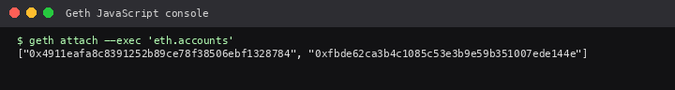

Step 2: Check validator account balance (ether)
web3.fromWei(eth.getBalance(eth.accounts[0]), "ether")
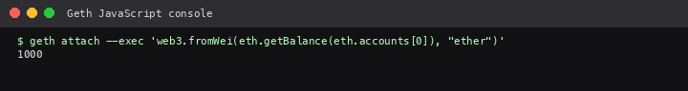

Step 3: Check user account balance (ether)
web3.fromWei(eth.getBalance(eth.accounts[1]), "ether")
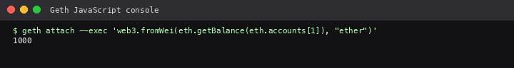

Step 4: Verify Clique validators
clique.getSigners()
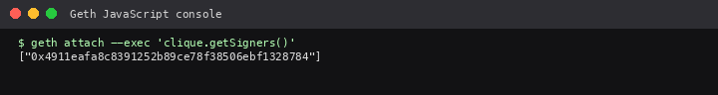

Step 5: Check network id
net.version
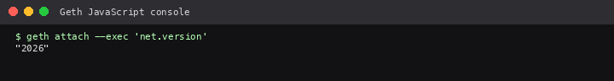

Step 6: Check current block number
eth.blockNumber
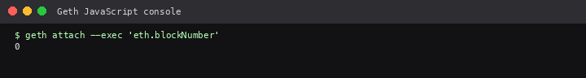

Step 7: View latest block
eth.getBlock("latest")
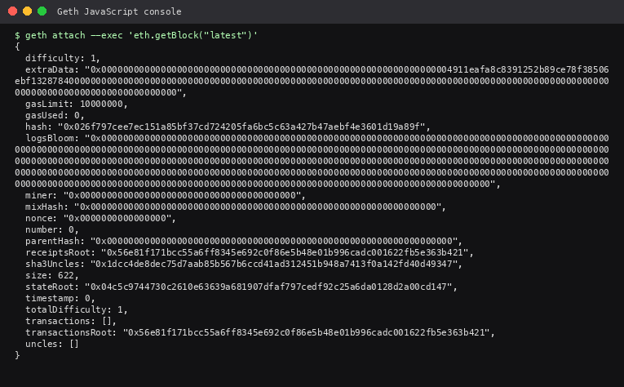

Step 8: Node id
admin.nodeInfo.id
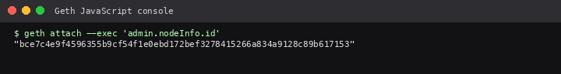

Step 9: Transaction pool status
txpool.status
